St Aidan’s Catholic Primary School

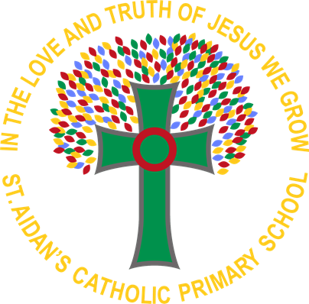

History Policy

2025 - 2026

**Intent- What we want our children to learn....**

At St. Aidan’s, we believe that high quality history education will help pupils gain a coherent knowledge and understanding of Britain’s past and that of the wider world. It should inspire pupils’ curiosity to know more about the past. Teaching should equip pupils to ask perceptive questions, think critically, weigh evidence, sift arguments, and develop perspective and judgement. History helps pupils to understand the complexity of people’s lives, the process of change, the diversity of societies and relationships between different groups, as well as their own identity and the challenges of their time.

We want to stimulate the children’s interest and understanding about the life of people who lived in the past. They develop a sense of identity and a cultural understanding based on their historical heritage. Thus they learn to value their own and other people’s cultures in modern multicultural Britain and, by considering how people lived in the past, they are better able to make their own life choices today. We also teach them to investigate these past events and, by so doing, to develop the skills of enquiry, analysis, interpretation and problem-solving.

We aim to ensure that all pupils:

* Know and understand the history of these islands are a coherent, chronological narrative, from the earliest times to the present day: how people’s lives have shaped this nation and how Britain has influenced and been influenced by the wider world.
* Know and understand significant aspects of the history of the wider world: the nature of ancient civilisation; the expansion and dissolution of empires; characteristic features of past non-European societies; achievements and follies of mankind.
* Gain and deploy a historically grounded understanding of abstract terms such as ‘empire’, ‘civilisation’, ‘parliament’ and ‘peasantry’.
* Understand historical concepts such as continuity and change, cause and consequence, similarity, difference and significance, and use them to make connections, draw contrasts, analyse trends, frame historically-valid questions and create their own structured accounts.
* Understand the methods of historical enquiry, including how evidence is used rigorously to make historical claims, and discern how and why contrasting arguments and interpretations of the past have been constructed.
* Gain historical perspective by placing their growing knowledge into different contexts, understanding the connections between local, regional, national and international history; between cultural, economic, military, political, religious and social; and between short- and long-term timescales.
* By the end of each key stage, pupils are expected to know, apply and understand the matters, skills and processes specified in the relevant programme of study.

**Implementation- What does learning in Geography look like?**

History teaching focuses on enabling children to think like historians. We place emphasis on examining historical artefacts and sources. In each key stage we given children the opportunity to visit sites of historical significance. We encourage visitors to come to school who help develop the wonder of history in our children. We recognise the importance of stories in history teaching and we regard this an important way of stimulating interest in the past. We focus on helping children understand that historical events can be interpreted in different ways and that they should always ask searching questions, such as ‘how do we know?’, about information they are given.

At St Aidan’s Catholic Primary School we use a variety of teaching and learning styles (visual, auditory and kinesthetic) for our pupils to enable them to access the curriculum as well as different learning groups (whole class, group work, paired work and individual work). This helps us to scaffold our learning to ensure all pupils access our curriculum. We recognise the fact that there are children of widely different abilities in all classes and we scaffold to provide suitable learning opportunities for all children by matching the challenge of the task to the ability of the child.

We achieve this by:

* Setting common tasks which are open-ended and can have a variety of responses;
* Setting differentiated tasks;
* Grouping children by different criteria where appropriate
* Providing resources of different complexity according to ability of child;
* Using classroom assistants to support the work of individual children or groups of children.

Our approach to teaching history is based upon a careful and considered balance of skills and content. The content is covered and linked together to form a clearer understanding of the past using carefully crafted enquiry questions. The knowledge is linked using the knowledge threads. Along with this increasing knowledge base, the children gain a greater understanding of history as a subject discipline. The skills are taught and applied using direct instruction, scaffolds, worked examples and guided practice.

**Curriculum**

We are working towards a dynamic, creative curriculum where historical experiences are integrated into other areas of learning. The children undertake a broad and balanced programme that takes account of abilities, aptitudes and physical, emotional and intellectual development. Through history the children learn a range of skills, concepts, attitudes and methods of working.

We use the National Curriculum as the basis for our curriculum planning, and from this, we have tailored our long-term plan to our children ensuring that we cover and use our local resources to enhance the children’s awareness of their own history and location. We ensure that there are opportunities for children of all abilities to develop their skills and knowledge in each unit and we build planned progression in the scheme of work so that the children are increasingly challenged as they move up through the school.

We carry out curriculum planning in history in three phases (long-term, medium-term and short-term). The long-term plan maps the history topics studied in each term during each key stage and the children study history topics in conjunction with other subjects, especially at Key Stage 1. Some topics have a particular historical focus and in Key Stage 2 we place an increasing emphasis on independent historical study. We teach the knowledge, skills and understanding set out in the National Curriculum through the corresponding programme of study. As the basis for our medium-term plans, we use the national scheme of work which gives details of each unit of work for each term. The history subject leader keeps and reviews these plans on a regular basis. The class teacher writes an outline for each history lesson (short-term plans). These list the specific learning objectives of each lesson.

Currently, the two terms used are substantive and disciplinary concepts. OFSTED have actively stated we do not need to use these terms but understanding the differences between them is important:

**Substantive knowledge** – the historical facts we teach that form the narratives of the curriculum.

Substantive knowledge concepts that run through our curriculum are:

* Society and Community
* Exploration and Invasion
* Power
* Conflict and disaster

**Disciplinary knowledge** – this is how we make use of the facts that are learned. Disciplinary knowledge is taught and embedded within the teaching of each unit of substantive knowledge. It is concerned with developing historical rational and critical thinking within enquiry, and can be categorised into 6 disciplinary concepts (Historical skills):

* Cause – selecting and combining information that might be deemed a cause and shaping it into a coherent causal explanation.
* Consequence – understanding the relationship between event and other future events.
* Continuity and change – analysing the pace, nature and extent of change.
* Similarities and differences – analysing the extent and type of difference between people, groups, experiences or places in the same historical period.
* Historical significance – understanding how and why historical events, trends and individuals are thought of as being important.
* Chronology – to place historical events in time order.

These disciplinary concepts form part of a broader method to help our pupils develop a historical perspective. They form part of a process, which enables our children to fully engage in a historical enquiry:

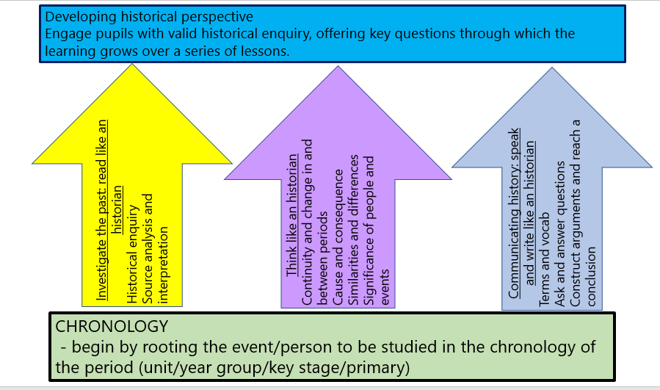

**Early years:** History is taught in Nursery and Reception as an integral part of topic work through child-initiated and adult led activities in the EYFS ‘Understanding of the World’ section of the EYFS goals. The children are given opportunity to find out about the past and present events in their own lives, and those of their families and other people they know. In the Foundation stage history makes significant contribution to developing a child’s understanding of the world through activities such as looking at pictures or discovering the meaning of old and new in relation to their own lives.

**Key Stage 1:** During Key Stage 1, pupils learn about people’s lives and lifestyles. They find out about significant men, women, children and events from recent and more distant Britain and the wider world. They listen, respond to stories and use sources of information to help them ask and answer questions. They learn how the past is different from the present.

**Key Stage 2:** During Key Stage 2, pupils learn about significant people, events and places from both recent and more distant past. They learn about changes and continuity in their own area, in Britain and in other parts of the world. They look at history in a variety of ways, for example from political, economical, technological and scientific, religious, cultural or aesthetic perspectives. They use different sources of information help them investigate the past both in depth and in overview, using dates and historical vocabulary to describe events, people and developments. They also learn that the past can be represented and interpreted in different ways.

**Teaching and Learning:**

The school uses a variety of teaching and learning styles in history lessons. Our principal aims is to develop the children’s knowledge, skills and understanding in history and we use a variety of teaching and learning styles in our history lessons. We believe in whole-class teaching methods and combine these with enquiry-based learning activities.

We believe children best learn when:

* They have access to and are able to handle artefacts
* They go on visits to museums and places of interest
* They have access to secondary sources such as books and photographs
* Visitors talk about personal experiences of the past
* They listen to and interact with stories from the past
* They undertake fieldwork by interviewing family and older friends about the changes in their own and other people’s lives
* They use drama and dance to act out historical events
* They are shown, or use independently, resources from the internet and videos
* They are able to use non-fiction books research
* They are provided with opportunities to work independently or collaboratively, to ask as well as answer historical questions

We recognise the fact that we have children of differing abilities in our classes, and so we provide suitable learning opportunities for all children by matching the challenge of the task to the ability of the child. We achieve this through a range of strategies, which are differentiated by task, expected outcomes and/or support from peers or adults.

**IMPACT**

St Aidan’s Catholic Primary School has personalised the National Curriculum to ensure children will know more and remember more by making links between subjects and year groups which deepen their learning. History, wherever possible, links with our termly themes and meets the needs of our children to provide knowledge of our local area as well as ensuring coverage of a diverse range of countries, landscapes and cultures. All children will have:

* A wider variety of skills linked to historical knowledge and understanding, and enquiry/investigative skills.
* Children will be able to refer to prior knowledge to support their learning in each year group and as a result, they will apply this to historical enquiry/investigation.
* A richer vocabulary which will enable to articulate their understanding of what they have been taught.
* High aspirations, which will see them through to further study, work and a successful adult life.

History Lead: Carly Wright

Last reviewed: July 2025