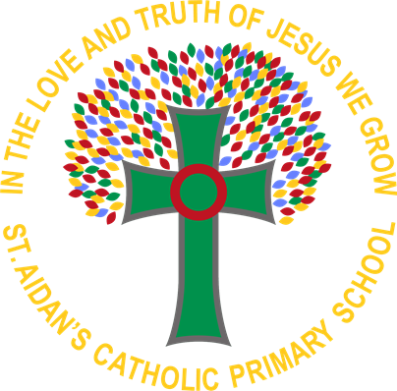

**St Aidan’s Catholic Primary School**

Geography Policy

Reviewed By: J Teer Date: July 2025

Review Date: July 2026

**The aims of our Geography Curriculum:**

* To equip pupils with substantive knowledge about diverse societies, economics and cultures, together with a deep understanding of the Earth’s key physical and human processes
* To encourage pupils to gain coherent disciplinary knowledge to develop skills to make sense of the world in which we live and how it has evolved
* To stimulate curiosity and imagination and build upon the child’s ‘personal geography’ by developing geographical skills, understanding and knowledge through studying places and themes.
* Where possible and relevant, links will be made between history and other curricular areas of study, key events nationally and locally, our individual student needs and prepare our students for KS3.
* To ensure pupils have appropriate subject knowledge, skills and understanding as set out in the EYFS and National Curriculum History Programmes of study.
* To fulfil the duties of the National Curriculum whereby schools must provide a balanced and broadly-based curriculum which promotes the spiritual, moral, cultural, mental and physical development of pupils and prepares them for the opportunities and responsibilities and experiences for later life.

**Intent- What we want our children to learn....**

As geographers, our children at St Aidan’s Catholic Primary School will gain a depth and breadth of knowledge and understanding of the world, its environments and places both near and far, and the processes that create and affect them both human and physical. Our geography curriculum encourages children to appreciate and understand how the world works and the interconnections between communities and cultures as well as allowing them to consider how they can themselves be respectful, sensitive and accepting of the world.

We believe children are active participants and investigators within geography and value fieldwork as an essential part of the curriculum allowing them to explore, make connections and comparisons and identify patterns and changes. Geographical enquiry and skills are embedded throughout teaching to ensure skills are transferable and progressive. Our curriculum allows our children exposure to experiences they wouldn’t otherwise have access to in order to gain a greater understanding of the wider world through the use of primary sources such as field work and secondary sources such as digital and physical maps, atlases, globes photographs and books.

Substantive knowledge sets out the content that is to be learned. The national curriculum and other geography education literature presents this through 4 interrelated curriculum concepts:

∙ locational knowledge

∙ place knowledge

∙ human and physical processes (the geography community also includes ‘environmental’ as part of this)

∙ geographical skills.

In geography, the substantive knowledge is based on the children’s knowledge of ‘places’ in our world; its continents, countries, cities and towns as well as physical features of our world; oceans, rivers, mountains and our local area. The children will gain a clear understanding of spatial sense as this is covered in every year group in Key Stage 1 and 2.

**Disciplinary Knowledge**

In geography, the disciplinary knowledge is how the children’s knowledge of the world is interpreted. The children will compare and contrast the places they learn about. The children will be given opportunities to draw their own maps, follow directions, read maps and interpret compass points. They will also be expected to comment and ask questions about the world and their local environment. We can break down this knowledge into Map Skills, Enquiry Skills and Fieldwork.

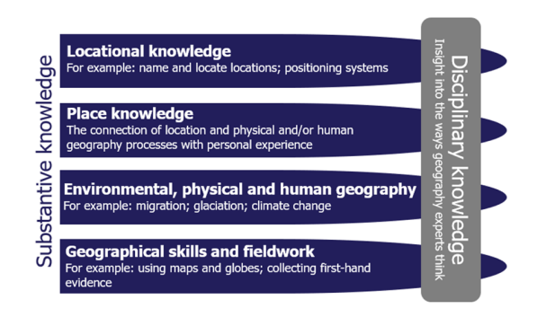

**Pupils in the Early Years Foundation Stage will learn:**

**About Understanding the World**

* **People and Communities**: Talk about past and present events in their own lives and in the lives of family members. They know that other children don’t always enjoy the same things, and are sensitive to this. They know about similarities and differences between themselves and others, and among families, communities and traditions.
* **The World**: Know about similarities and differences in relation to places, objects, materials and living things. They talk about the features of their own immediate environment and how environments might vary from one another. They make observations of animals and plants and explain why some things occur, and talk about changes.

### **Pupils in Key Stage 1 will:**

* Study their school, grounds and local area and contrast with another area in the United Kingdom and abroad, finding out about the physical features of the area and the people who live there using fieldwork and photographs
* Learn about and locate the main countries and cities within the United Kingdom and the seas surrounding, using maps, atlases and globes, as well as identify and locate the main continents and oceans around the world
* Carry out geographical enquiry inside and outside the classroom, observing and recording weather and identifying seasonal changes in the United Kingdom
* Be introduced to geographical vocabulary to refer to human and physical features of the environment

**Pupils in Key Stage 2 will:**

* Investigate, compare and contrast a variety of people, places and environments in the United Kingdom and around the world using photographs, maps, atlas’ and globes
* Discover how and why the earth is changing and how this affects them and future generations
* Identify and locate European countries and countries in North and South America, counties and cities within the United Kingdom and the significance of longitude, latitude and time zones
* Carry out geographical enquiry inside and outside the classroom, asking questions and using maps, atlas, globes and compasses linking to computing and other areas of the curriculum

**Implementation- What does learning in Geography look like?**

At St Aidan’s Catholic Primary School, teachers bring the geography curriculum to life and engage children through a range of exciting topics and a variety of stimuli, including key texts, studies of famous geographers, workshops and school trips. As a staff, we maintain strong links to the National Curriculum and incorporate an enquiry-based approach to children’s learning about the world through a geographical lens.

We have developed our curriculum using a range of resources and making links with other subjects wherever possible, including: Art, Music, Science, RE, English, Maths and History. Links are made to termly themes and other curriculum subjects where appropriate, and these develop our Learning Journeys on our Medium Term Plans. Long-term plans identify individual geographical units taught across the year group phases and the key skills developed in each unit. A planned progression of skills built into the geography programme: Connected Geography, means that the children are increasingly challenged as they move through the school. This is supported by a wide range of high quality resources such as local modern and historical maps.

We believe educational visits help to promote learning in all aspects of geography and we aim to incorporate it in all areas of the curriculum. In particular, children study at depth our local area allowing regular opportunities to explore the area they live and learn in. Our curriculum is designed so that we can make full use of geographical places of interest in our local area, including the coastline that we are situated on.

At St Aidan’s geography is taught discretely over three half terms per year, however some units are carried over to allow for depth and breadth of learning within that subject area.

Pupils work in mixed ability groups following our co-operative learning approach and to promote oracy, and a variety of teaching approaches such as whole-class lessons, group, paired and individual work and discussions are experienced by pupil’s during their geography lessons.

**Emphasis on Vocabulary**

As a school, we have a strong emphasis on the value of quality-first teaching in relation to subject specific vocabulary. Pupils are exposed to a range of specific vocabulary outlined in the progression map and knowledge organisers. This will involve children building their vocabulary with scaffolding both in their books and on display in the classroom to explore the meaning and apply these new words to their learning. Teachers are expected to ask high quality questions at the beginning of each lesson which recaps on previous vocabulary knowledge to ensure recall from the children. This will be done in a variety of ways to ensure all children are engaged including never heard the word, BINGO games and quizzes.

**Assessment**

Pupil progress is assessed and monitored throughout the year through teacher planning and organisation. Teachers follow the school’s Feedback policy for formative assessment, responsive feedback and whole class feedback. Alongside this, there will be an end of topic assessment. At the end of each topic the children are given a geographical enquiry based question to answer based on the topic they have been studying. The term’s work will build up to answer this question and children will be exposed to knowledge organisers to help them contain the information needed for the end of the topic assessment piece. The children will then be given time to answer this question using the work they have done over the term - we will use responsive marking to give children areas for development. The children will then be provided with the opportunity to edit and improve their piece of writing to develop this further and consolidate their understanding.

Each unit of work will be assessed against the skills and knowledge outlined in the ‘Knowledge Organiser’ created for each unit of work. This will be recorded for each class and handed to the subject leader at the end of each taught unit along with examples of work and planning used. These assessments will be used to inform the subject leader on the progression of pupil’s and the class teacher for future planning purposes.

Parents are informed of their child’s progress throughout the year through parent’s evenings and via annual reports sent home in the summer term.

**IMPACT**

St Aidan’s Catholic Primary School has personalised the National Curriculum to ensure children will know more and remember more by making links between subjects and year groups which deepen their learning. Geography, wherever possible, links with with our termly themes and meets the needs of our children to provide knowledge of our local area as well as ensuring coverage of a diverse range of countries, landscapes and cultures. All children will have:

* A wider variety of skills linked to geographical knowledge and understanding, and enquiry/investigative skills.
* Children will be able to refer to prior knowledge to support their learning in each year group and as a result, they will apply this to geographical enquiry/investigation.
* A richer vocabulary which will enable to articulate their understanding of what they have been taught.
* High aspirations, which will see them through to further study, work and a successful adult life.

Geography Lead: Carly Wright

Last reviewed: July 2025